CSCI 5722 Computer Vision, Spring 2020
Student: Yinbo Chen
Instructor: Fleming
Homework 5

a.
For retrieving features, the original features grab functions are ComputeColorFeatures and ComputePositionColorFeatures. The first one simply returns three color channels R, G, B as three different matrix dimensions. The second method returns three layers as the features as well as adds the position coordinations X, Y to layers 4 and 5. To make a comparison, I perform color filters, edges and gradient features in ComputeFeatures function, I add various filters (mean filter, Gaussian filter, and median filter) on color channels to exam whether the filter can affect the feature transforms or not. I also perform the edges detection in this function. The edges detection algorithm which I implemented is Sobel. I retrieve edge features from each color channel and add them to layers 4 to 6. For gradient features, I use MatLab built-in function imgradinetxy with algorithm Sobel on each color channel and save x, y directional gradients to layers 1 to 6.
Then compute the mean accuracy for all images. The result shows below with set of parameters ( k = 5, ClusteringMethod = ‘kmeans’, normalization = true, resize = 1, maxPixels = 50000):

 | ComputeFeatures | ComputeColorFeatures | ComputePositionColorFeatures
color | N/A | 0.8731 | N/A
Color+ Position | N/A | N/A | 0.8810
Mean-filter | 0.8740 | N/A | N/A
Gaussian-filter | 0.8663 | N/A | N/A
Median-filter | 0.8787 | N/A | N/A
Edge | 0.8615 | N/A | N/A
Gradient | 0.7294 | N/A | N/A
Edge+ Gradient | 0.7415 | N/A | N/A
Position | 0.8766 | N/A | N/A
Mean+Position | 0.8707 | N/A | N/A
Gaussian+Position | 0.8801 | N/A | N/A
Median+Position | 0.8759 | N/A | N/A

Setting of parameters ( k = 5, ClusteringMethod = ‘hac’, normalization = true, resize = 0.2, maxPixels = 2500):
Function | ComputerFeatures | ComputeColorFeatures | ComputePositionColorFeatures
color | N/A | 0.8608 | N/A
Color+ Position | N/A | N/A | 0.8557
Mean-filter | 0.8501 | N/A | N/A
Gaussian-filter | 0.8675 | N/A | N/A
Median-filter | 0.8741 | N/A | N/A
Edge | 0.7247 | N/A | N/A
Gradient | 0.7088 | N/A | N/A
Edge+ Gradient | 0.7071 | N/A | N/A
Position | 0.8523 | N/A | N/A
Mean+Position | 0.8404 | N/A | N/A
Gaussian+Position | 0.8589 | N/A | N/A
Median+Position | 0.8194 | N/A | N/A
From the date, I found when using KMEANS as a clustering method. Processing color using image filter does improve the accuracy of segmentation but it’s very limited. Compare to the original image color without any filter, the accuracy is 0.8731. The best-filtered accuracy is 0.8787 when using a median filter. However, performing position features, the accuracy increases to 0.8810. The positioning feature is more important than the color feature. Adding position features can significantly improve the accuracy. But the accuracy of combining filtered images with positon features are worse than the accuracy which uses original color combine with position coordination directly.
When using HAC as a clustering method. The best accuracy is 0.8741 when using a median filter. The color feature is more important than the position feature.

The normalization method which I employed is: first to use the built-in mean function to compute all pixels’ values in the features vector. Then, using std function computes the variance of each feature. The last step is to norm feature into the range 0 to 1 by using mean and variance.

b.
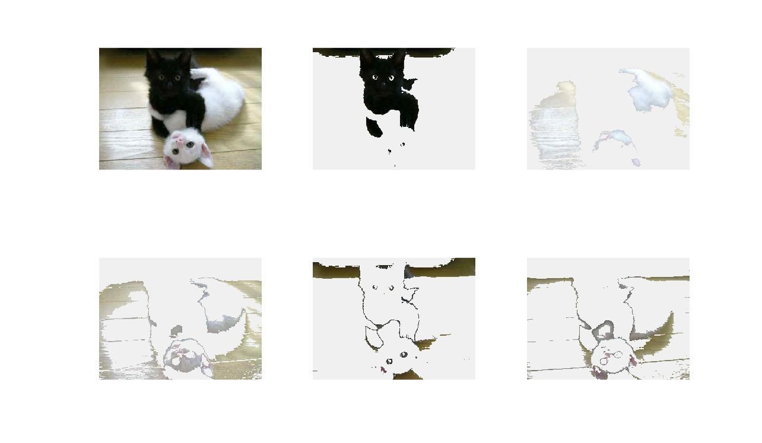
Image: the-black-white-kittens.jpg
K :5
clusteringMethod: Kmeans
features method: ComputeColorFeatures
normalization: false
resize :1
result: unsuccessful

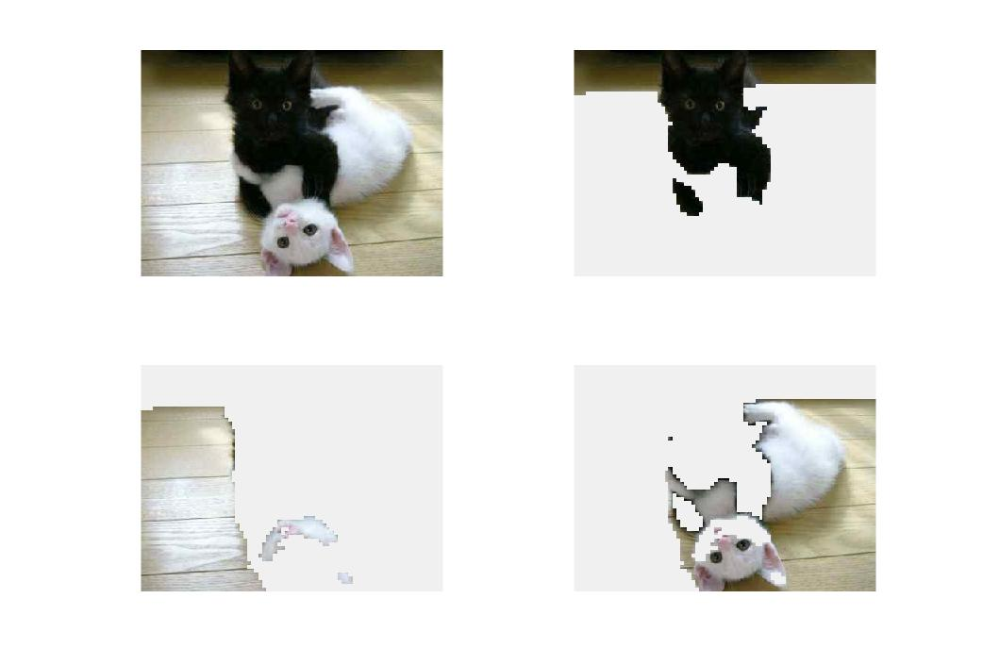
Image: the-black-white-kittens.jpg
K :3
clusteringMethod: Hac
features method: ComputePositionColorFeatures
normalization:true
resize :0.2
result: unsuccessful

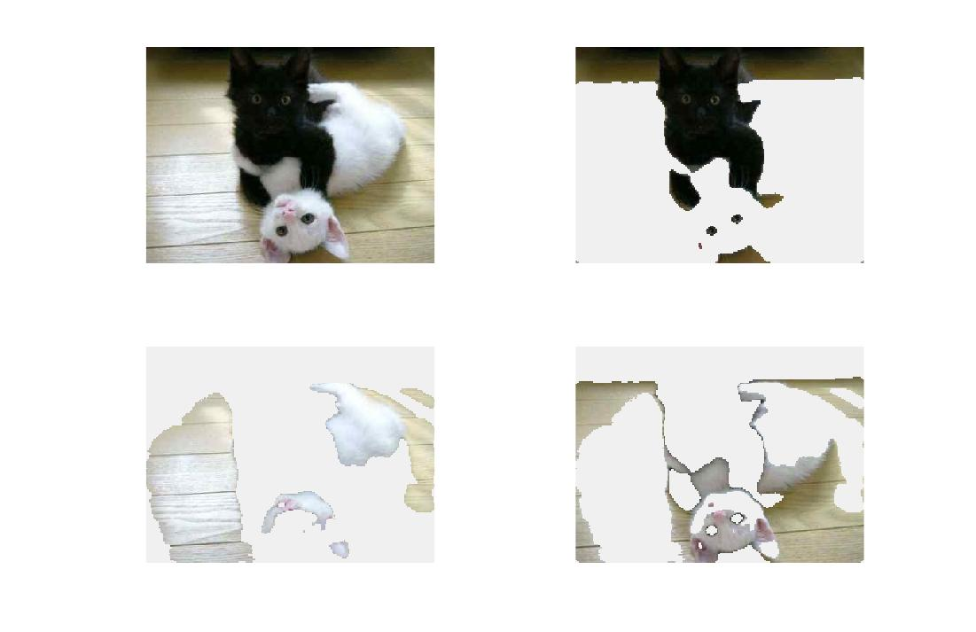
Image: the-black-white-kittens.jpg
K :3
clusteringMethod: Kmeans
features method: ComputeFeatures (median filter)
normalization:true
resize :0.5
result: unsuccessful

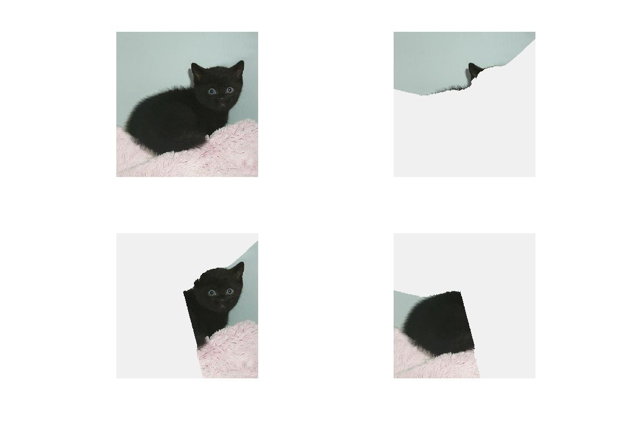
Image: black_kitten_star.jpg
K :3
clusteringMethod: Kmeans
features method: ComputePositionColorFeatures
normalization: false
resize :1
result: unsuccessful

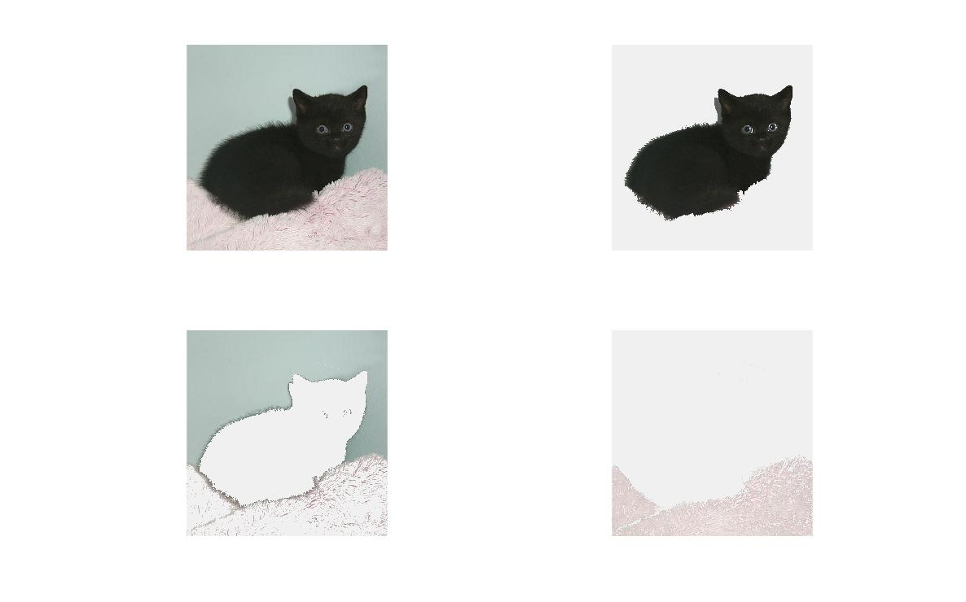
Image: black_kitten_star.jpg
K :3
clusteringMethod: Kmeans
features method: ComputeColorFeatures
normalization: true
resize :1
result: successful

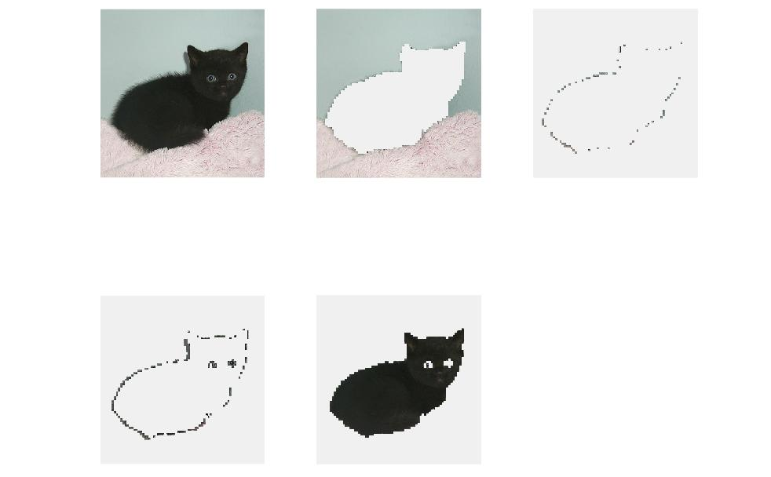
Image: black_kitten_star.jpg
K :4
clusteringMethod: Hac
features method: ComputeColorFeatures
normalization: true
resize :0.1
result: successful

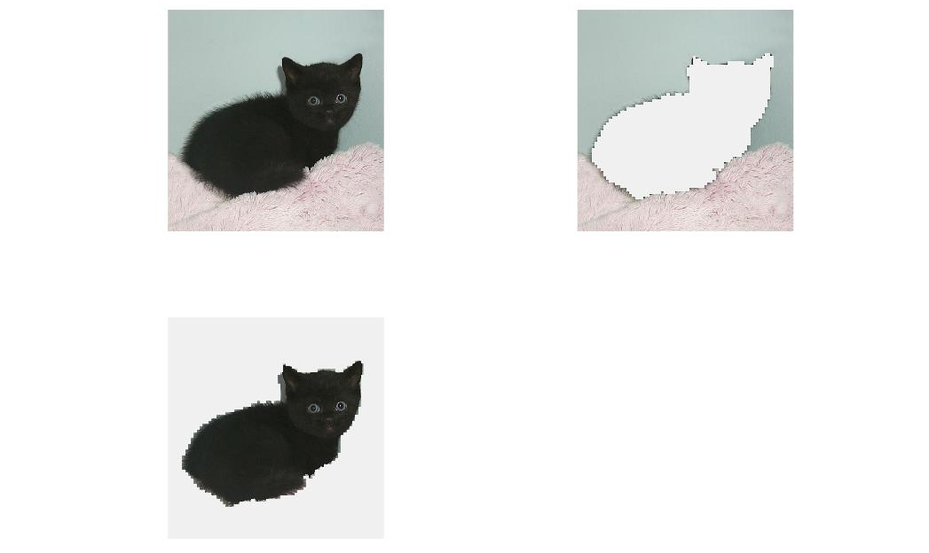
Image: black_kitten_star.jpg
K :2
clusteringMethod: Hac
features method: ComputePositionColorFeatures
normalization: false
resize :0.1
result: successful
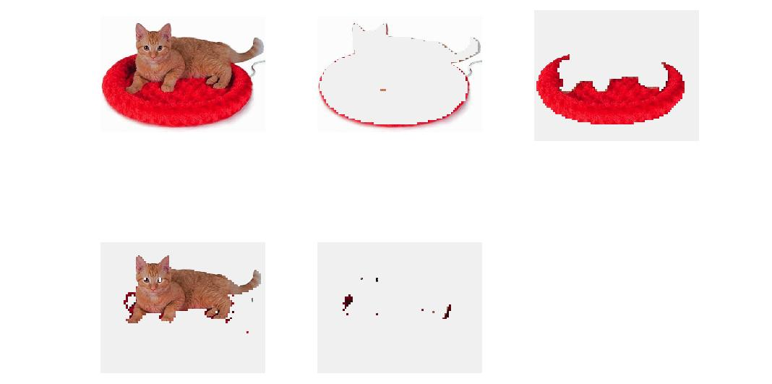
Image: Cat_Bed.jpg
K :4
clusteringMethod: Hac
features method: ComputeColorFeatures
normalization: true
resize :0.2
result: successful

c.
- What effect does each of the segmentation parameters(feature transform, feature normalization, number of clusters, clustering method, resize) have on the quality of the final segmentation?
Using color alone always gives me good segmentation results. Using a positioning feature may or may not give a good result. Do not use gradient and edges detection alone. The result seems not related to employing a segmentation experiment. Feature normalization will reduce some noise but it does time-consuming. The number of clusters affects the final result. Sometimes you need to predict the number of clustering. The clustering method also takes a big affection for a good segmentation. Using combined color and position features will get a good result by using Kmeans as a clustering-method. The HAC clustering method is more suitable for using color features and more accuracy than the Kmeans-method. Resize is necessary, especially when using the HAC as a clustering-method.

- How does each of these parameters affect the speed of computing a segmentation?
If other parameters aren’t changed, HAC is much slower than Kmeans. If you use HAC as a clustering-method, you need to resize the original image for better time management. For Kmeans-method, a higher K value takes a long time for computing. It seems not increasing time-consuming by setting a higher K under a HAC-method. For set up a normalization as well as set a higher resize value need more time to calculate, whatever under Kmeans or HAC.
- How do the properties of an image affect the difficulty of computing a good segmentation for that image?
Firstly, for getting a better result, the original image needs to have clear boundaries between the foreground and background. Secondly, with a clean background and not having lots of noise are essential for retrieving a good segmentation.

d.
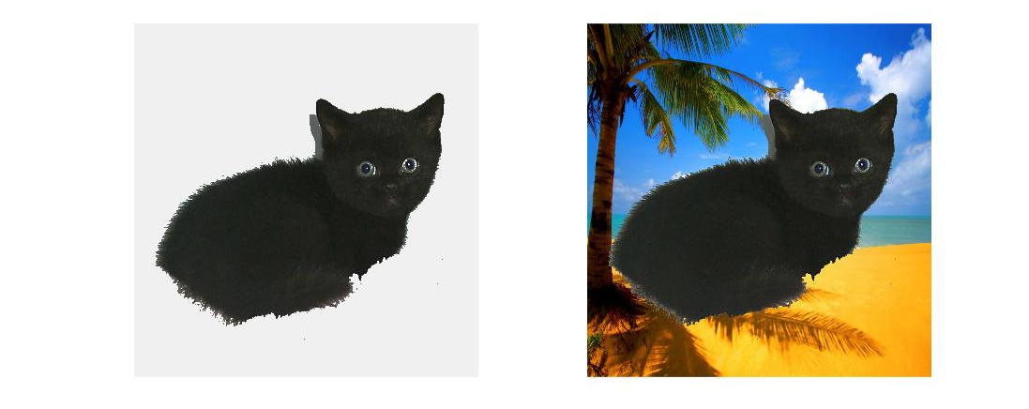
This segmentation is generated by using Kmeans clustering-method with parameters below:
The number of clusters is 3. Using the ComputerColorFeatures as a feature function. Setting normalization to true. Considering a Kmeans method is not a time-consuming function, so using a default setting that resize value is 1.

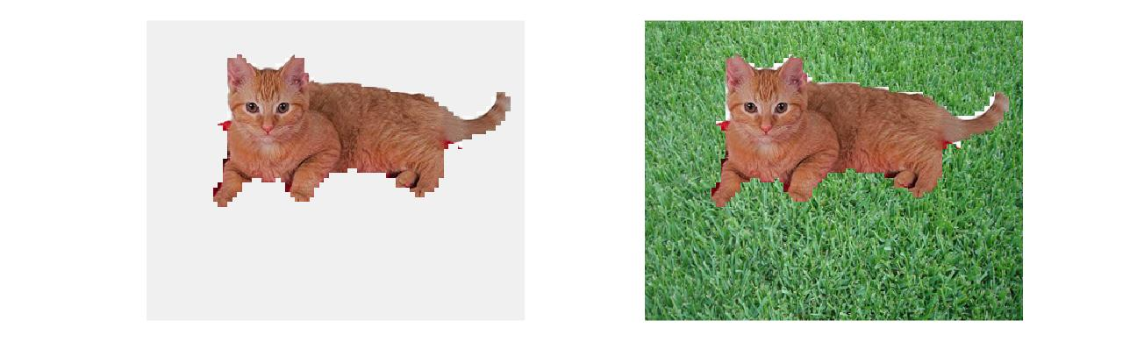
This segmentation is generated by using Hac clustering-method with parameters below:
The number of clusters is 7. Using the ComputerFeatures with median-filter as a feature function. Setting normalization to false and resize the image with value 0.2.

e.

Feature  Transform | Feature Normalization | Clustering  Method | Number  of clusters | Resize  (or max pixels) | Mean  accuracy
Color | True | Kmeans | 2 | 50000 | 0.8270
Color | True | Kmeans | 8 | 50000 | 0.8832
Color | False | Kmeans | 2 | 50000 | 0.7967
Color | False | Kmeans | 8 | 50000 | 0.8912
Color | True | Hac | 2 | 2500 | 0.8132
Color | True | Hac | 8 | 2500 | 0.8790
Color | False | Hac | 2 | 2500 | 0.8186
Color | False | Hac | 8 | 2500 | 0.8845
Color | False | Kmeans | 2 | 2500 | 0.7981
Color | False | Kmeans | 8 | 2500 | 0.8843
Color+Position | True | Kmeans | 2 | 50000 | 0.8262
Color+Position | True | Kmeans | 8 | 50000 | 0.9056
Color+Position | False | Kmeans | 2 | 50000 | 0.8015
Color+Position | False | Kmeans | 8 | 50000 | 0.9007
Color+Position | True | Hac | 2 | 2500 | 0.8324
Color+Position | True | Hac | 8 | 2500 | 0.8949
Color+Position | False | Hac | 2 | 2500 | 0.8167
Color+Position | False | Hac | 8 | 2500 | 0.8841
Color+Position | False | Kmeans | 2 | 2500 | 0.8296
Color+Position | False | Kmeans | 8 | 2500 | 0.8895

- Based on your quantitative experiments, how do each of the segmentation parameters affect the quality of the final foreground-background segmentation?
These quantitative experiments show that a higher number of clusters contributes to providing a good segmentation. Also, the data shows that Kmeans is better than Hac even under the same max pixels’ setting. The feature normalization does provide a positive affection to improve segmentation, but the effect is slight. The highest mean accuracy is employed by Kmeans with a combined color and position feature function. Compare to Hac, Kmeans method is more sensitive to the position feature which is added can provide a significant improvement. However, Hac is more sensitive by the number of clusters. Due to the limitation of a computer’s performance, I can’t perform high max pixels during using the Hac clustering-method.
- Are some images simply more difficult to segment correctly than others? If so, what are the qualities of these images that cause the segmentation algorithm to perform poorly?
Yes, it is. The image with the lowest accuracy is the-black-white-kittens. It’s hard to make a good segmentation due to the two opposite colors in the foreground, one of them is hard to distinguish with the light background because the boundaries are barely to see. This issue also happens in the images young-calico-cat and cat_mouse.
- In section a, I employ several image filters as feature functions. I find that the Hac method is sensitive to color than position. In section e, I find when the number of clusters reaching the minimum number 2, the accuracy is inversely proportional to the max pixels when performing a Kmeans algorithm.

